Anthropogenic plant communities of the Iberian Atlantic ecoregion

# Introduction

Anthropogenic vegetation is the set of plant communities that occur as a direct consequence of human activities, and is chiefly composed by the weed vegetation of arable fields and the ruderal vegetation of human settlements and their surroundings (Lososova & Simonova 2008). The formation of anthropogenic vegetation in temperate Europe has been characterized by a constant enrichment produced by the arrival of alien species: first archaeophytes starting in the Neolithic and peaking in the Bronze Age; and then neophytes from the Modern Age to the present day (Brun 2009). Synanthropic archaeophytes include many Mediterranean taxa that started their expansion into temperate areas during the Mid-Holocene warm period, but it is difficult to disentangle to what extent this expansion was favored by human activities and/or ongoing climatic changes (Cayless & Tipping 2002; Cordova & Lehmann 2003), especially in southern European areas close to the transition between the Mediterranean and the temperate climates (Celesti‐Grapow et al. 2009). Meanwhile, synanthropic neophytes include many American, African and Asian taxa that arrived as a consequence of the global trade networks established by the Western European colonial powers (Lenzner et al. 2022). In the last century, anthropogenic vegetation has shown a decrease in species richness and diversity (Pysek et al. 2004), as rare synanthropic species have become rarer, and neophytes have increased their abundance at the expense of natives and archaeophytes (Lososova & Simonova 2008).

The anthropogenic communities of human-made habitats make up an important part of the supply of natural elements in urban and peri-urban habitats (Kowarik 2018). In densely-populated city landscapes, the plant communities that colonize urban vacant lots (Johnson et al. 2017) are a useful biodiversity resource with high ecological and societal potential (Anderson & Minor 2017). Anthropogenic vegetation cover can also impact regional-level extreme climatic events (Stefanon et al. 2014). Furthermore, many synanthropic plants can accumulate heavy metals in their biomass (Kostryukova et al. 2017), making them valuable candidates for nature-based solutions such as bioremediation and restoration of degraded landscapes (Song et al. 2019).

The Iberian Atlantic ecoregion (a.k.a. Cantabrian Mixed Forests ecoregion; NW Iberian Peninsula) has a long history of human habitation dating back to the Cantabrian Upper Paleolithic (Straus 2005). This, together with its transitional position at the border between the temperate and Mediterranean climatic zones of Europe (Loidi 2017), suggests a long regional history for archaeophyte-rich anthropogenic plant communities, likely supporting a high diversity of anthropogenic plant communities with both temperate and Mediterranean floristic elements (Díaz González 2020). Historical trade links with America and Asia, together with the warm and humid temperate climate, have made the region a hotspot for neophyte invasions (**Checklist?**). Recent post-industrial land-use changes have left large areas with abandoned industrial sites (i.e., brownfields), whose management and restoration requires an understanding of anthropogenic communities able to colonize or restore them (Gallego et al. 2016; Matanzas et al. 2021). Although there is a long tradition of studying weed and ruderal communities in the ecoregion (Aedo et al. 1988; González et al. 1988; Merino, González, González, et al. 1988; Merino, González, Morales, et al. 1988) there is a current need for an ecoregional-level synthesis that revises the classification and updates in accord with recent developments in European vegetation science (Mucina et al. 2016) and habitat classification (Chytrý et al. 2020). In this article we have performed such a synthesis with two main objectives: (1) provide an updated classification of anthropogenic plant communities in the Iberian Atlantic ecoregion, and (2) describe the main patterns of variation in terms of species traits and ecological and disturbance preferences.

# Methods

We performed all data analyses with R version 4.3.1 (R Core Team 2023), using the R package ‘tidyverse’ (Wickham et al. 2019) for data processing and visualization. The original datasets, as well as R code for analysis and creation of the manuscript can be accessed at the GitHub repository <https://github.com/efernandezpascual/manmade>.

## Study ecoregion

We studied the anthropogenic plant communities of the Iberian Atlantic ecoregion, i.e. the territories with a temperate climate in the north-western Iberian Peninsula. Our study ecoregion broadly corresponds with the Cantabrian Mixed Forests ecoregion *sensu* Olson *et al.* (2001), with the Iberian part of the European Atlantic province *sensu* Rivas-Martínez *et al.* (2017) and with the Iberian section of the Atlantic biogeographical region of the European Environmental Agency (<https://www.eea.europa.eu/data-and-maps/figures/biogeographical-regions-in-europe-2>). To define in detail the study ecoregion we did a fine-scale revision of its geographic borders at high spatial resolution using the most recent biogeographical map of the Iberian Atlantic territories (Fernández Prieto et al. 2020). The revised Iberian Atlantic ecoregion encompasses 79,891 km2 of Portugal, Spain and France. Its climate is temperate with average monthly temperatures ranging from 6 to 20°C, and with total annual precipitation between 1,100 and 2,600 mm, with some areas having warm-dry summers but without the distinctive 2-month drought of the Mediterranean climate (Moreno et al. 1990). Nonetheless, the Iberian Atlantic ecoregion is located at the transition between the temperate and the Mediterranean climates in southern Europe.

## Definition of anthropogenic vegetation

To define our target vegetation, we followed the definitions of anthropogenic vegetation in the recent classification of the vegetation of Europe by Mucina *et al.* (2016). In our study area, this potentially includes the vegetation classes *Polygono-Poetea annuae*, *Papaveretea rhoeadis*, *Digitario sanguinalis-Eragrostietea minoris*, *Chenopodietea*, *Sisymbrietea*, *Artemisietea vulgaris*, *Epilobietea angustifolii* and *Bidentetea*. For a complete synthesis, we added the class *Cymbalario-Parietarietea diffusae* included by Mucina *et al.* (2016) in the vegetation of rock crevices and screes, since this class encompasses the vegetation of human-made walls in our ecoregion. For the nomenclature of sintaxa we follow Mucina *et al.* (2016) for alliances and higher ranks, and Rivas-Martínez *et al.* (2001) for associations.

## Vegetation data

As vegetation data for our analyses, we obtained all vegetation relevés (i.e. records of plant species coexisting in a given sampling plot at a given date) from our study ecoregion that were available in SIVIM, the Iberian and Macaronesian Vegetation Information System (Font et al. 2012). These were 28,775 relevés representing all vegetation types (i.e. anthropogenic, semi-natural, and natural). Since these relevés were sampled by different authors throughout the decades, there was no taxonomical consistency among them, so we homogenized all taxon names for the whole dataset. We followed the methodology applied by Jiménez-Alfaro *et al.* (2021) to the Cantabrian Mountains, an area within the study ecoregion which includes c. 80% of the ecoregional flora, to create a new taxonomical checklist for the ecoregion, based on the Euro+Med Plantbase (2006). For vascular plants not included in Euro+Med (e.g. several *Quercus* or *Salix* hybrids, non-native species, etc.), as well as for bryophytes, we followed Plants of the World Online (POWO 2023). We excludedFungi and algae. For analytical purposes, we merged taxa into aggregates when: (1) there were sets of very close species with a difficult identification in the field (e.g. *Viola riviniana* + *V. reichenbachiana* + *V. sylvestris* = *Viola riviniana* aggr.), (2) the taxon was recently separated in different taxa (e.g. *Hedera helix* + *Hedera hibernica* + *Hedera canariensis* = *Hedera helix* aggr.) and (3) the authors of the relevé were not able to identify or recognize infraspecific taxa (e.g. all *Narcissus pseudonarcissus* subspecies and varieties = *Narcissus pseudonarcissus* aggr.).

For mapping purposes, we improved the geographical information of the SIVIM relevés using a downscaling procedure. The original position of vegetation relevés in SIVIM was originally recorded as 10 km x 10 km (52.2%) and 1 km x 1 km (47.8%) grid cells. We assigned more precise geographic coordinates to these plots using the elevation recorded originally by the authors and a digital elevation model (DEM) of the Iberian Peninsula at 200-m grid resolution. From the original 10 km x 10 km or 1 km x 1 km grid cell of each relevé, we (1) kept only those 200-m cells that agreed with the relevé’s elevation (± 50 m); (2) randomly selected one of these 200-m cells; and (3) assigned to the relevé the coordinate of the 200-m cell’s centroid, in decimal degrees. By doing this, the plots were downscaled at higher resolution within their cells, assuming that 200-m cells at similar elevations within the same grid cell also have similar climatic conditions.

To identify anthropogenic relevés in the SIVIM database we followed two complementary approaches. First, we used the expert system followed to classify vegetation plots into EUNIS pan-European habitat classification types (Chytrý et al. 2020). This expert system uses the floristic composition of plots to assign them to habitat types depending on the presence and abundance of characteristic species. We used the habitats assigned by the expert system to retrieve plots that had been assigned to any habitat related to the vegetation classes we had previously defined: all habitats in the level 1 code V (vegetated man-made habitats), plus level 3 codes R55 (lowland moist or wet tall-herb and fern fringe) and R57 (herbaceous forest clearing vegetation). Additionally, we retrieved relevés that had been classified by the original authors of the relevé into any sintaxa belonging to our target anthropogenic vegetation classes (**Supplementary 1**). This produced an initial pool of 3,160 relevés from SIVIM, to which we added 89 relevés of urban or peri-urban plant communities sampled by us or extracted from the local literature (different from SIVIM; Zabaleta Mendizábal 1990; Uría Arizaga 2020). After initial exploration of this dataset using Two-Way Indicator Species Analysis (TWINSPAN) (Roleček et al. 2009), we identified 652 outlier relevés which either did not belong to the target anthropogenic classes or to the geographical area of the ecoregion. We removed these, leaving a dataset of 2,508 relevés for data analyses: 2,419 relevés from SIVIM, originally recorded in 89 publications (see **Supplementary 2**); plus 89 relevés added by us.

## Statistical analyses

Definition of target alliances and training dataset. As a previous step before classification, we prepared a revised checklist of potential anthropogenic alliances that could be present in our study ecoregion, based on regional sintaxonomical checklists (Izco et al. 2000; Díaz González 2020; Gómez 2020) and recent revisions at the European level (Mucina et al. 2016; Preislerová et al. 2022). Then, we filtered our dataset to extract a subset with the relevés which had been assigned by the authors to any of these alliances. We used sequential TWINSPANs to conducta preliminary numerical classification of this subset, attempting to re-match the relevés into the *a priori* defined checklist of alliances. We used 3 pseudospecies cut levels (0, 15, 25) with a minimum group size of 10 plots and Sørensen’s average dissimilarity, and the R package ‘twinspanR’ (Zelený 2021) to do the TWINSPANs. To start, we did a TWINSPAN classification into 15 clusters, followed by separate TWINSPANS within each cluster. This preliminary TWINSPAN allowed us to (1) validate which alliances were present in the study ecoregion; and (2) prepare a training dataset for semi-supervised classification (see below).

Semi-supervised classification. Next, we applied a semi-supervised classification to the whole dataset. Semi-supervised classification uses a training subset of *a priori* classified relevés to classify a secondary subset of unclassified relevés (De Cáceres et al. 2010). Our training subset included all the relevés that (1) had been classified by the authors of the relevé into any of the alliances that we had validated during the previous TWINSPANs, and (2) had also been classified by us into these alliances during our TWINSPANs. The secondary subset included all the relevés which did not meet these two criteria. Our goal was to refine and not to simply extend the classification, so we applied the semi-supervised classification to the whole dataset, i.e. we allowed relevés from the training subset to be re-assigned to other groups during the classification. In addition, semi-supervised classification can create new groups to place data points that do not match the already existing *a priori* groups. Furthermore, we applied a noise clustering fuzzy algorithm, which allows the relevés to be classified either into the *a priori* groups or into a ‘noise’ group which includes outliers and transitional relevés (Wiser & De Cáceres 2013). We set the fuzziness coefficient to a low value (m = 1) to accommodate a high number of transitional relevés; and we set the distance to the noise class to d = 1. We performed this analysis with the R package ‘vegclust’ (De Cáceres et al. 2010). We used pairwise PERMANOVA (with 100,000 iterations, Euclidean distances and Holm’s p-value correction) fitted with the R package ‘RVAideMemoire’ (Herve 2023) to test the significance of the final vegetation groups; along with Detrended Correspondence Analysis (DCA) as implemented in the R package ‘vegan’ (Oksanen et al. 2022) to visualize the relationships between the groups.

Characteristic species and EUNIS habitat regionalization. We calculated sets of characteristic species (Chytrý et al. 2020) for each of the final vegetation groups. We defined dominant species as species with more than 25% cover in at least 5% of the relevés of the group; constant species as species with a frequency higher than 50% in the group; and diagnostic species as species with an ‘IndVal’ value with a p-value lower than 0.05, as calculated with the R package ‘labdsv’ (Roberts 2016) using 1.000.000 iterations. Additionally, we assigned to each group a regionalized level 4 EUNIS habitat code, using pre-existing codes when they existed, and creating new codes when not.

Community traits and ecological requirements. To describe the resulting vegetation groups, we compiled a dataset of species traits and ecological preferences for the species pool of the classified relevés. For each species, we extracted from *Flora iberica* (1987) its maximum height, its median month of flowering, the length of the flowering period, and whether it was a neophyte or not. From FloraVeg.EU (2023) we extracted the species’ life forms and kept ‘therophyte’ and ‘geophyte’ for further analysis since these two categories had the largest contribution to variance as per an exploratory Principal Component Analysis (PCA) performed using the R package ‘FactoMineR’ (Lê et al. 2008). We also extracted the ecological indicator values (Dengler et al. 2023) and the disturbance indicator values (Midolo et al. 2023) of each species. In the case of the ecological and disturbance indicators, we assigned values to species lacking them by (1) calculating weighted average values of the species with values for each plot (weighting by species cover), and (2) assigning to the missing species the weighted average values of the plots where they were present (weighting by species cover). Then, we calculated the relevés´ community-weighted mean (weighting by species cover) for each trait and ecological preference, and explored the main axes of variation using PCA, separately for species traits and ecological preferences.

# Results

## Overview of the classification

Our revision of the literature produced a provisional list of 38 anthropogenic vegetation alliances that could be present in the Iberian Atlantic ecoregion (**Supplementary 3**). In our study dataset (n = 2,508 relevés), there were 2,201 relevés that had been assigned by the original authors to one of these alliances. We used these 2,201 relevés for a preliminary re-classification based on TWINSPAN, attempting to re-match the relevés into the *a priori* defined checklist of 38 alliances. This procedure allowed us to validate 28 alliances as present in the ecoregion. A total of 1,725 relevés had been classified by both the original authors and our TWINSPAN into these alliances, and these became our training subset for the semi-supervised classification. Attempts by the semi-supervised classification to create new groups resulted in new groups with no ecological significance, and thus we kept the original 28 alliances as final vegetation groups (**Table 1**). Most of the alliances had a wide distribution in the ecoregion according to our dataset (**Figure 1**), although five of them (*Caucalidion lappulae*, *Linario polygalifoliae-Vulpion alopecuri*, *Convolvulo arvensis-Agropyrion repentis*, *Senecionion fluviatilis*, *Paspalo-Agrostion semiverticillati*) had only isolated occurrences in a few points towards the southern limit of the Iberian Atlantic territories. The regional literature (different from SIVIM) included in our dataset recognized 72 associations (**Supplementary 4**) within these alliances. The semi-supervised classification with noise clustering resulted in the final classification of 2,081 relevés into 28 alliances and 427 relevés left out in the noise group.

Focusing on the classified plots, the dataset included 1,167 taxa or taxa aggregates. Of these, 101 were neophytes (i.e. 9% of the species pool). Regarding life forms, the species pool was dominated by hemicryptophytes (43%) and therophytes (41%). The 10 most frequent species were *Ochlopoa annua* (621 occurrences), *Urtica dioica* (592), *Sonchus oleraceus* (540), *Stellaria media* (516), *Capsella bursa-pastoris* (390), *Polygonum aviculare* (375), *Dactylis glomerata* (363), *Senecio vulgaris* (332) and *Anisantha sterilis* (301). Considering only those relevés with the most frequent plot size (20 m2, n = 256 relevés), the average species richness per plot was 16 (minimum = 3, maximum = 37).

DCA ordination of the floristic composition of the classified relevés (**Fig. 2**) suggested a high consistency of the vegetation classes *Cymbalario-Parietarietea diffusae*, *Polygono-Poetea annuae*, *Papaveretea rhoeadis*, *Digitario sanguinalis-Eragrostietea minoris*, *Sisymbrietea* and *Bidentetea*. The alliances belonging to the two perennial ruderal vegetation classes (*Artemisietea vulgaris* and *Epilobietea angustifolii*) were mixed together. The winter-annual class *Chenopodietea* also showed high heterogeneity, especially because of the isolation of the altered dune alliance *Linario polygalifoliae-Vulpion alopecuri*.

## Community-level traits and ecological preferences

PCA ordination of the community-weighted means of the species traits (**Fig. 3A**) indicated that the first two axes explained 65% of the variability. The major contributors to axis 1 (41% variance explained) were community height, proportion of geophytes, mean month of flowering and proportion of therophytes; it separated taller communities with more geophytes and later flowering (classes *Artemisietea vulgaris*, *Epilobietea angustifolii* and *Bidentetea*) from shorter communities with more therophytes and earlier flowering (classes *Polygono-Poetea annuae*, *Papaveretea rhoeadis* and *Sisymbrietea*). The major contributors to axis 2 (24% variance explained) were proportion of neophytes and width of the flowering season; it separated communities with more neophytes and longer flowering seasons (classes *Bidentetea*, *Digitario sanguinalis-Eragrostietea minoris* and *Polygono-Poetea annuae*) from communities with less neophytes and shorter flowering seasons (classes *Artemisietea vulgaris*, *Epilobietea angustifolii* and *Chenopodietea*).

PCA ordination of the community-weighted means of the species ecological and disturbance preferences (**Fig. 3B**) indicated that the first two axes explained 56% of the variability. The major contributors to axis 1 (35% variance explained) were disturbance frequency, soil disturbance, mowing frequency and light requirements; it separated communities thriving with frequent disturbances in open situations (classes *Polygono-Poetea annuae*, *Sisymbrietea*, *Digitario-Eragrostietea* and *Papaveretea rhoeadis*) from communities preferring less frequent disturbances and more shady areas (classes *Cymbalario-Parietarietea diffusae*, *Epilobietea angustifolii* and *Bidentetea*). The major contributors to axis 2 (21% variance explained) were nutrient requirements and disturbance severity; it separated more nitrophilous communities adapted to more severe disturbances (classes *Digitario-Eragrostietea*, *Sisymbrietea* and *Epilobietea angustifolii*) from less nitrophilous communities adapted to lower intensity disturbances (classes *Cymbalario-Parietarietea diffusae*, *Artemisietea vulgaris* and *Chenopodietea*).

## Classified anthropogenic plant communities

***Cymbalario-Parietarietea diffusae*** Vegetation of human-made walls.

1. *Galio valantiae-Parietarion judaicae* Vegetation of dry walls. Occupies warmer, drier and more nutrient-rich situations than the other alliance in the class, has a shorter flowering season and is more adapted to disturbances (**Fig. 4**). Wide distribution in the ecoregion (**Fig. 1**). Diagnostic species (**Supplementary 5**): *Parietaria judaica* aggr., *Centranthus ruber*, *Asplenium trichomanes*.
2. *Cymbalario-Asplenion* Vegetation of mesic walls. Occupies colder, wetter and less nutrient-rich situations than the other alliance in the class, has a longer flowering season and is less adapted to disturbances (**Fig. 4**). Wide distribution in the ecoregion (**Fig. 1**). Diagnostic species (**Supplementary 5**): *Cymbalaria muralis*.

***Polygono-Poetea annuae*** Dwarf vegetation of heavily-trampled sites.

1. *Polycarpion tetraphylli* Dwarf-annual trampled vegetation of warm and sunny sites. Occupies warmer, sunnier and less nutrient-rich situations than the other alliances in the class and has an earlier flowering season (**Fig. 4**). Wide distribution in the ecoregion, specially along the coast and in the more Mediterranean valleys of the interior (**Fig. 1**). Diagnostic species (**Supplementary 5**): *Sagina apetala*, *Plantago coronopus*, *Crassula tillaea*, *Spergularia marina*.
2. *Polygono-Coronopodion* Dwarf-annual trampled vegetation of dry sites. Occupies colder, drier and more nutrient-rich situations than the other alliances in the class, and has a higher proportion of neophytes (**Fig. 4**). Wide distribution in the ecoregion (**Fig. 1**). Diagnostic species (**Supplementary 5**): *Matricaria suaveolens*, *Polygonum aviculare*.
3. *Saginion procumbentis* Dwarf trampled vegetation of mesic sites. Occupies colder, wetter and more nutrient-rich situations than the other alliance in the class, and is less dominated by therophytes (**Fig. 4**). Distribution concentrated in the central part of the ecoregion (**Fig. 1**). Diagnostic species (**Supplementary 5**): *Sagina procumbens*, *Bryum argenteum*.

***Papaveretea rhoeadis*** Annual weed vegetation of crops and gardens.

1. *Caucalidion lappulae* Annual weed vegetation of cereal crops on base-rich soils. Adapted to more frequent and severe disturbances than the other alliances in the class (**Fig. 4**). Distribution mostly limited to the more Mediterranean valleys south of the Cantabrian Mountains (**Fig. 1**). Diagnostic species (**Supplementary 5**): *Cyanus segetum*, *Papaver rhoeas*, *Trifolium arvense*, *Anacyclus clavatus*, *Valerianella eriocarpa*.
2. *Scleranthion annui* Annual weed vegetation of cereal crops on base-poor soils. Occupies more acidic soils than the other alliances in the class, and flowers earlier (**Fig. 4**). Wide distribution in the ecoregion, but specially in the west, where acidic bedrocks dominate (**Fig. 1**). Diagnostic species (**Supplementary 5**): *Mibora minima*, *Rumex acetosella*.
3. *Oxalidion europeae* Annual weed vegetation of gardens and root crops. Occupies wetter, shadier and more nutrient-rich situations than the other alliances in the class, has a longer flowering season and a higher proportion of neophytes (**Fig. 4**). Wide distribution in the ecoregion (**Fig. 1**). Diagnostic species (**Supplementary 5**): *Stellaria media*, *Veronica persica*.

***Digitario sanguinalis-Eragrostietea minoris*** Summer-annual C4 weed vegetation.

1. *Spergulo arvensis-Erodion cicutariae* Summer-annual C4 weed vegetation. Late-flowering alliance rich in neophytes and grasses, occurring in highly-disturbed and nutrient-rich soils (**Fig. 4**). Wide distribution in the ecoregion (**Fig. 1**). Diagnostic species (**Supplementary 5**): *Digitaria sanguinalis*, *Echinochloa crus-galli*, *Chenopodium album*, *Amaranthus hybridus* aggr.

***Chenopodietea*** Winter-annual ruderal vegetation.

1. *Allion triquetri* Geophyte-rich fringe vegetation. Occupies warmer and shadier situations than the other alliances in the class, has a higher proportion of geophytes and a lower proportion of therophytes, and is adapted to less frequent disturbances (**Fig. 4**). Wide distribution in the ecoregion (**Fig. 1**). Diagnostic species (**Supplementary 5**): *Urtica membranacea*, *Smyrnium olusatrum*, *Tradescantia fluminensis*.
2. *Geranio pusilli-Anthriscion caucalidis* Winter-annual fringe vegetation. Occupies situations similar to the previous alliance, but in colder sites, and is dominated by therophytes instead of geophytes (**Fig. 4**). Mostly distributed in the more Mediterranean valleys south of the Cantabrian Mountains (**Fig. 1**). Diagnostic species (**Supplementary 5**): *Geranium lucidum*, *Anthriscus caucalis*.
3. *Chenopodion muralis* Low-growth winter-annual ruderal vegetation. Occupies colder situations than the other alliances in the class and more often disturbed sites, and has a longer and later flowering season (**Fig. 4**). Sparse occurrence throughout the ecoregion (**Fig. 1**). Diagnostic species (**Supplementary 5**): *Malva neglecta*, *Urtica urens*.
4. *Echio-Galactition tomentosae* Tall-herb winter-annual ruderal vegetation. Occupies drier, sunnier and less nutrient-rich situations than the other alliances in the class (**Fig. 4**). Mostly distributed in the west of the ecoregion (**Fig. 1**). Diagnostic species (**Supplementary 5**): *Galactites tomentosus*, *Coleostephus myconis*, *Anisantha rigida*.
5. *Linario polygalifoliae-Vulpion alopecuri* Ephemeral annual vegetation of disturbed coastal dunes. Occupies drier and more nutrient-poor situations than the other alliances in the class (**Fig. 4**) and has a high number of coastal dune species. Isolated occurrence in the southern coasts of the ecoregion (**Fig. 1**). Diagnostic species (**Supplementary 5**): *Vulpia alopecuros*, *Malcolmia littorea*, *Crucianella maritima*, *Artemisia campestris* aggr.

***Sisymbrietea*** Summer-annual ruderal vegetation.

1. *Sisymbrion officinalis* Summer-annual ruderal vegetation. Rich in therophytes and adapted to severe disturbances (**Fig. 4**). Wide distribution in the ecoregion (**Fig. 1**). Diagnostic species (**Supplementary 5**): *Hordeum murinum*, *Sisymbrium officinale*.

***Artemisietea vulgaris*** Perennial ruderal vegetation of dry sites.

1. *Convolvulo arvensis-Agropyrion repentis* Semiruderal grasslands. Occupies wetter and shadier situations than the other alliances in the class, and has a higher proportion of geophytes and grasses (**Fig. 4**). Isolated occurrence in the south of the ecoregion (**Fig. 1**). Diagnostic species (**Supplementary 5**): *Poa compressa*, *Elytrigia repens*, *Potentilla reptans*, *Valerianella locusta*.
2. *Carduo carpetani-Cirsion odontolepidis* Thistle ruderal vegetation of warm sites. Occupies warmer situations than the other thistle alliance in the class (**Fig. 4**). Mostly distributed in the Cantabrian Mountains (**Fig. 1**). Diagnostic species (**Supplementary 5**): *Onopordum acanthium*.
3. *Cirsion richterano-chodati* Thistle ruderal vegetation of cold sites. Occupies colder situations than the other thistle alliance in the class (**Fig. 4**). Mostly distributed in the Cantabrian Mountains (**Fig. 1**). Diagnostic species (**Supplementary 5**): *Cirsium eriophorum*, *Carduus carpetanus*, *Carduus nutans* aggr.
4. *Dauco-Melilotion* Biennial ruderal vegetation. Occupies wetter situations than the two thistle alliances in the class, and has a higher proportion of therophytes (**Fig. 4**). Sparse occurrence throughout the ecoregion (**Fig. 1**). Diagnostic species (**Supplementary 5**): *Helminthotheca echioides*, *Daucus carota*, *Melilotus albus*, *Foeniculum vulgare*.

***Epilobietea angustifolii*** Perennial ruderal vegetation of mesic to wet sites.

1. *Geo urbani-Alliarion officinalis* Low-herb short-lived semiruderal and fringe vegetation. Occupies shadier and less disturbed situations than the other alliances in the class, and has a higher proportion of therophytes and shorter plants (**Fig. 4**). Wide distribution in the ecoregion (**Fig. 1**). Diagnostic species (**Supplementary 5**): *Urtica dioica*.
2. *Arction lappae* Low-herb short-lived ruderal vegetation. Occupies sunnier and more frequently-disturbed situations than the other alliances in the class, and has a higher proportion of therophytes and shorter plants (**Fig. 4**). Distribution concentrated in the Cantabrian Mountains (**Fig. 1**). Diagnostic species (**Supplementary 5**): *Oxybasis rubra*, *Senecio duriaei*.
3. *Balloto-Conion maculati* Tall-herb perennial ruderal vegetation. Occupies warmer situations than the other alliances in the class (**Fig. 4**). Distribution concentrated in the Cantabrian Mountains and the east of the ecoregion (**Fig. 1**). Diagnostic species (**Supplementary 5**): *Sambucus ebulus*.
4. *Aegopodion podagrariae* Tall-herb perennial vegetation of forest margins and clearings. Occupies shadier and less disturbed situations than the other alliances in the class (**Fig. 4**). Sparse occurrence throughout the ecoregion (**Fig. 1**). Diagnostic species (**Supplementary 5**): *Anthriscus sylvestris*, *Heracleum sphondylium*, *Galium aparine*.
5. *Epilobion angustifolii* Tall-herb perennial vegetation of forest margins and clearings in acidic soils. Occupies colder, nutrient-poorer, more acidic and less disturbed situations than the other alliances in the class (**Fig. 4**). Distributed towards the west of the ecoregion (**Fig. 1**). Diagnostic species (**Supplementary 5**): *Epilobium angustifolium*, *Digitalis purpurea*, *Luzula lactea*.
6. *Cynancho-Convolvulion sepium* Tall-herb vegetation of nutrient-rich riparian habitats. Occupies wetter situations and less disturbed situations than the other alliances in the class, and has a later flowering season (**Fig. 4**). Dispersed throughout the ecoregion (**Fig. 1**). Diagnostic species (**Supplementary 5**): *Eupatorium cannabinum*, *Angelica sylvestris*, *Picris hieracioides*.
7. *Senecionion fluviatilis* Tall-herb vegetation of nutrient-rich river banks and ditches. Occupies warmer and wetter situations than the other alliances in the class, flowers later, has taller plants and is highly dominated by neophytes and geophytes (**Fig. 4**). Isolated occurrence in the western coast of the ecoregion (**Fig. 1**). Diagnostic species (**Supplementary 5**): *Arundo donax*, *Silene latifolia*.

***Bidentetea*** Summer-annual pioneer vegetation of temporarily-flooded sites.

1. *Bidention tripartitae* Summer-annual pioneer vegetation of temporarily-flooded sites. Occupies nutrient-richer sites than the other alliance in the class and has a higher proportion of therophytes (**Fig. 4**). Dispersed throughout the ecoregion (**Fig. 1**). Diagnostic species (**Supplementary 5**): *Persicaria hydropiper*, *Bidens frondosus*, *Lythrum salicaria*.
2. *Paspalo-Agrostion semiverticillati* Summer-annual pioneer vegetation of temporarily-flooded and warm sites. Occupies warmer and wetter situations than the other alliance in the class, has a higher proportion of neophytes and has a longer flowering season (**Fig. 4**). Isolated occurrences in the south of the ecoregion (**Fig. 1**). Diagnostic species (**Supplementary 5**): *Paspalum distichum*, *Cyperus longus*, *Schoenoplectus lacustris*.

# Discussion

The major driver of variation in trampled community composition is soil moisture (Golovanov et al. 2023).

In medieval Switzerland, summer and winter weeds communities could not be distinguished (Karg 1995).

The class *Digitario sanguinalis-Eragrostietea minoris* includes thermophilic vegetation dominated by C4 plants that occupies arable land as well as trampled and ruderal sites (Nemec et al. 2011).

Anthropogenic vegetation composition is sensitive to micro-scale management decisions, such as the ownership of domestic dogs (Pal et al. 2013).

Neophytes were more represented in early successional anthropogenic communities (Pysek et al. 2004).

Arable land plants were mainly therophytes and alien species; while ruderal habitats were richer in perennials and C strategists (Silc 2010).

Compare proportion of neophytes to other areas (Silc et al. 2012; @ Simonova & Lososova 2008)

Neophytes have no special preferences for local habitat conditions and their highest proportion was found mainly in disturbed habitats at low elevations. (Simonova & Lososova 2008)

Therophytes and hemicryptophytes were most abundant in the life form spectra (Tabasevic et al. 2021)

# Data availability

The original datasets, as well as R code for analysis and creation of the manuscript can be accessed at the GitHub repository <https://github.com/efernandezpascual/manmade>. Upon publication, a version of record of the repository will be deposited in Zenodo.

# References

2006.

Aedo, C., Herrera, M., Prieto, J.F., & Díaz, T. 1988. Datos sobre la vegetación arvense de la Cornisa Cantábrica. *Lazaroa* 9: 241–254.

Anderson, E.C., & Minor, E.S. 2017. [Vacant lots: An underexplored resource for ecological and social benefits in cities](https://doi.org/10.1016/j.ufug.2016.11.015). *Urban Forestry & Urban Greening* 21: 146–152.

Brun, C. 2009. [Biodiversity changes in highly anthropogenic environments (cultivated and ruderal) since the Neolithic in eastern France](https://doi.org/10.1177/0959683609336559). *Holocene* 19: 861–871.

Castroviejo, S. 1987. *Flora iberica*. Real Jardín Botánico, CSIC, Madrid.

Cayless, S.M., & Tipping, R.M. 2002. [Data on mid-Holocene climatic, vegetation and anthropogenic interactions at Stanshiel Rig, southern Scotland](https://doi.org/10.1007/s003340200023). *Vegetation History and Archaeobotany* 11: 201–210.

Celesti‐Grapow, L., Alessandrini, A., Arrigoni, P.V., Banfi, E., Bernardo, L., Bovio, M., Brundu, G., Cagiotti, M.R., Camarda, I., Carli, E., Conti, F., Fascetti, S., Galasso, G., Gubellini, L., La Valva, V., Lucchese, F., Marchiori, S., Mazzola, P., Peccenini, S., Poldini, L., Pretto, F., Prosser, F., Siniscalco, C., Villani, M.C., Viegi, L., Wilhalm, T., & Blasi, C. 2009. [Inventory of the non‐native flora of Italy](https://doi.org/10.1080/11263500902722824). *Plant Biosystems - An International Journal Dealing with all Aspects of Plant Biology* 143: 386–430.

Chytrý, M., Tichý, L., Hennekens, S.M., Knollová, I., Janssen, J.A.M., Rodwell, J.S., Peterka, T., Marcenò, C., Landucci, F., Danihelka, J., Hájek, M., Dengler, J., Novák, P., Zukal, D., Jiménez-Alfaro, B., Mucina, L., Abdulhak, S., Aćić, S., Agrillo, E., Attorre, F., Bergmeier, E., Biurrun, I., Boch, S., Bölöni, J., Bonari, G., Braslavskaya, T., Bruelheide, H., Campos, J.A., Čarni, A., Casella, L., Ćuk, M., Ćušterevska, R., De Bie, E., Delbosc, P., Demina, O., Didukh, Y., Dítě, D., Dziuba, T., Ewald, J., Gavilán, R.G., Gégout, J.-C., Giusso del Galdo, G.P., Golub, V., Goncharova, N., Goral, F., Graf, U., Indreica, A., Isermann, M., Jandt, U., Jansen, F., Jansen, J., Jašková, A., Jiroušek, M., Kącki, Z., Kalníková, V., Kavgacı, A., Khanina, L., Yu. Korolyuk, A., Kozhevnikova, M., Kuzemko, A., Küzmič, F., Kuznetsov, O.L., Laiviņš, M., Lavrinenko, I., Lavrinenko, O., Lebedeva, M., Lososová, Z., Lysenko, T., Maciejewski, L., Mardari, C., Marinšek, A., Napreenko, M.G., Onyshchenko, V., Pérez-Haase, A., Pielech, R., Prokhorov, V., Rašomavičius, V., Rodríguez Rojo, M.P., Rūsiņa, S., Schrautzer, J., Šibík, J., Šilc, U., Škvorc, Ž., Smagin, V.A., Stančić, Z., Stanisci, A., Tikhonova, E., Tonteri, T., Uogintas, D., Valachovič, M., Vassilev, K., Vynokurov, D., Willner, W., Yamalov, S., Evans, D., Palitzsch Lund, M., Spyropoulou, R., Tryfon, E., & Schaminée, J.H.J. 2020. [EUNIS Habitat Classification: Expert system, characteristic species combinations and distribution maps of European habitats](https://doi.org/10.1111/avsc.12519). *Applied Vegetation Science* 23: 648–675.

Cordova, C.E., & Lehmann, P.H. 2003. [Archaeopalynology of synanthropic vegetation in the <i>chora</i> of Chersonesos, Crimea, Ukraine](https://doi.org/10.1016/s0305-4403(03)00044-x). *Journal of Archaeological Science* 30: 1483–1501.

De Cáceres, M., Font, X., & Oliva, F. 2010. [The management of vegetation classifications with fuzzy clustering](https://doi.org/10.1111/j.1654-1103.2010.01211.x). *Journal of Vegetation Science* 21: 1138–1151.

Dengler, J., Jansen, F., Chusova, O., Hüllbusch, E., Nobis, M.P., Van Meerbeek, K., Axmanová, I., Bruun, H.H., Chytrý, M., Guarino, R., Karrer, G., Moeys, K., Raus, T., Steinbauer, M.J., Tichý, L., Tyler, T., Batsatsashvili, K., Bita-Nicolae, C., Didukh, Y., Diekmann, M., Englisch, T., Fernández-Pascual, E., Frank, D., Graf, U., Hájek, M., Jelaska, S.D., Jiménez-Alfaro, B., Julve, P., Nakhutsrishvili, G., Ozinga, W.A., Ruprecht, E.-K., Šilc, U., Theurillat, J.-P., & Gillet, F. 2023. [﻿Ecological Indicator Values for Europe (EIVE) 1.0](https://doi.org/10.3897/vcs.98324). *Vegetation Classification and Survey* 4:

Díaz González, T.E. 2020. La vegetación del Principado de Asturias (España) (esquema sintaxonómico de las comunidades vegetales). *Boletín de Ciencias de la Naturaleza del RIDEA* 55: 339–646.

Fernández Prieto, J.A., Amigo, J., Bueno, Á., Herrera, M., Rodríguez-Guitián, M.A., & Loidi, J. 2020. Notas sobre el Catálogo de comunidades de plantas vasculares de los territorios iberoatlánticos (I). *Naturalia Cantabricae* 17–37.

FloraVeg.EU. 2023. FloraVeg.EU – Database of European Vegetation, Habitats and Flora. www.floraveg.eu. Accessed December 2023.

Font, X., Pérez-García, N., Biurrun, I., Fernández-González, F., & Lence, C. 2012. The Iberian and Macaronesian Vegetation Information System (SIVIM, www. sivim. info), five years of online vegetation’s data publishing. *Plant Sociology* 49: 89–95.

Gallego, J.R., Rodríguez-Valdés, E., Esquinas, N., Fernández-Braña, A., & Afif, E. 2016. [Insights into a 20-ha multi-contaminated brownfield megasite: An environmental forensics approach](https://doi.org/10.1016/j.scitotenv.2015.09.153). *Science of The Total Environment* 563-564: 683–692.

Golovanov, Y.M., Abramova, L.M., Arepieva, L.A., Devyatova, E.A., & Ovcharova, N.V. 2023. [Review of plant communities of the class <i>Polygono arenastri- Poetea annuae</i> in the Russian Federation](https://doi.org/10.14258/turczaninowia.26.2.13). *Turczaninowia* 26: 147–169.

Gómez, J.A.D. 2020. Sintaxonomía de las comunidades vegetales de Cantabria, 2020. *Flora Montiberica* 56–92.

González, T.E.D., Merino, Á.P., Cembranos, L.H., Morales, C.P., García, F.L., & Alfonso, A.T. 1988. Estudio de los herbazales nitrófilos vivaces y comunidades ruderal viarios de la provincia de León (NW de España). Study of vivacious nitrophilous grasslands and roadside communities of León province (NW of Spain). *Acta Botanica Barcinonensia*

Herve, M. 2023. RVAideMemoire: Testing and Plotting Procedures for Biostatistics. R package version 0.9-83-2. https://CRAN.R-project.org/package=RVAideMemoire.

Izco, J., Amigo, J., & García-San León, D. 2000. Análisis y clasificación de la vegetación de Galicia (España), II. La vegetación herbácea. *Lazaroa* 21:

Jiménez-Alfaro González, F. de B., Carlón, L., Fernández Pascual, E., Cires Rodríguez, E., Díaz González, T.E., & Nava Fernández, H.S. 2021. Checklist of the vascular plants of the Cantabrian Mountains. *Mediterranean Botany*

Johnson, A.L., Borowy, D., & Swan, C.M. 2017. Land use history and seed dispersal drive divergent plant community assembly patterns in urban vacant lots. *Journal of Applied Ecology*. doi: [10.1111/1365-2664.12958](https://doi.org/10.1111/1365-2664.12958)

Karg, S. 1995. PLANT DIVERSITY IN LATE-MEDIEVAL CORNFIELDS OF NORTHERN SWITZERLAND. *Vegetation History and Archaeobotany* 4: 41–50.

Kostryukova, A.M., Mashkova, I.V., Krupnova, T.G., & Shchelkanova, E.E. 2017. [STUDY OF SYNANTHROPIC PLANTS OF THE SOUTH URAL](https://doi.org/10.21660/2017.40.3519). *International Journal of Geomate* 13: 60–65.

Kowarik, I. 2018. [Urban wilderness: Supply, demand, and access](https://doi.org/10.1016/j.ufug.2017.05.017). *Urban Forestry & Urban Greening* 29: 336–347.

Lê, S., Josse, J., & Husson, F. 2008. FactoMineR: an R package for multivariate analysis. *Journal of Statistical Software* 25: 1–18.

Lenzner, B., Latombe, G., Schertler, A., Seebens, H., Yang, Q., Winter, M., Weigelt, P., Kleunen, M. van, Pyšek, P., Pergl, J., Kreft, H., Dawson, W., Dullinger, S., & Essl, F. 2022. [Naturalized alien floras still carry the legacy of European colonialism](https://doi.org/10.1038/s41559-022-01865-1). *Nature Ecology & Evolution* 6: 1723–1732.

Loidi, J. 2017. *The Vegetation of the Iberian Peninsula*. Springer.

Lososova, Z., & Simonova, D. 2008. Changes during the 20th century in species composition of synanthropic vegetation in Moravia (Czech Republic). *Preslia* 80: 291–305.

Matanzas, N., Afif, E., Díaz, T.E., & Gallego, J.R. 2021. [Phytoremediation Potential of Native Herbaceous Plant Species Growing on a Paradigmatic Brownfield Site](https://doi.org/10.1007/s11270-021-05234-9). *Water, Air, & Soil Pollution* 232: 290.

Merino, A.P., González, T.E.D., González, M.E.G., Pacheco, M.J.L., & Puente, E. 1988. Datos sobre los cardales y tobales (Onopordetea acanth¡ i) en la provincia de León. *Lazaroa* 10: 987–88.

Merino, Á.P., González, T.E.D., Morales, C.P., García, E.P., González, M.E.G., & Alfonso, A.T. 1988. Aportaciones al conocimiento de las comunidades de malas hierbas de cultivo en la provincia de León. *Acta Botanica Barcinonensia*

Midolo, G., Herben, T., Axmanová, I., Marcenò, C., Pätsch, R., Bruelheide, H., Karger, D.N., Aćić, S., Bergamini, A., Bergmeier, E., Biurrun, I., Bonari, G., Čarni, A., Chiarucci, A., De Sanctis, M., Demina, O., Dengler, J., Dziuba, T., Fanelli, G., Garbolino, E., Giusso del Galdo, G., Goral, F., Güler, B., Hinojos-Mendoza, G., Jansen, F., Jiménez-Alfaro, B., Lengyel, A., Lenoir, J., Pérez-Haase, A., Pielech, R., Prokhorov, V., Rašomavičius, V., Ruprecht, E., Rūsiņa, S., Šilc, U., Škvorc, Ž., Stančić, Z., Tatarenko, I., & Chytrý, M. 2023. [Disturbance indicator values for European plants](https://doi.org/10.1111/geb.13603). *Global Ecology and Biogeography* 32: 24–34.

Moreno, J.M., Pineda, F.D., & Rivas‐Martinez, S. 1990. Climate and vegetation at the Eurosiberian‐Mediterranean boundary in the Iberian Peninsula. *Journal of vegetation science* 1: 233–244.

Mucina, L., Bültmann, H., Dierßen, K., Theurillat, J.-P., Raus, T., Čarni, A., Šumberová, K., Willner, W., Dengler, J., García, R.G., Chytrý, M., Hájek, M., Di Pietro, R., Iakushenko, D., Pallas, J., Daniëls, F.J.A., Bergmeier, E., Santos Guerra, A., Ermakov, N., Valachovič, M., Schaminée, J.H.J., Lysenko, T., Didukh, Y.P., Pignatti, S., Rodwell, J.S., Capelo, J., Weber, H.E., Solomeshch, A., Dimopoulos, P., Aguiar, C., Hennekens, S.M., & Tichý, L. 2016. [Vegetation of Europe: hierarchical floristic classification system of vascular plant, bryophyte, lichen, and algal communities](https://doi.org/10.1111/avsc.12257). *Applied Vegetation Science* 19: 3–264.

Nemec, R., Lososova, Z., Drevojan, P., & Zakova, K. 2011. [Synanthropic vegetation of the <i>Eragrostion cilianensi</i>-<i>minoris</i> alliance in the Czech Republic](https://doi.org/10.2478/s11756-011-0108-0). *Biologia* 66: 1019–1026.

Oksanen, J., Simpson, G., Blanchet, F., Kindt, R., Legendre, P., Minchin, P., O’Hara, R., Solymos, P., Stevens, M., Szoecs, E., Wagner, H., Barbour, M., Bedward, M., Bolker, B., Borcard, D., Carvalho, G., Chirico, M., De Caceres, M., Durand, S., Evangelista, H., FitzJohn, R., Friendly, M., Furneaux, B., Hannigan, G., Hill, M., Lahti, L., McGlinn, D., Ouellette, M., Cunh, E., Smith, T., Stier, S., Ter Braak, C., & Weedon, J. 2022. vegan: Community Ecology Package. R package version 2.6-4. https://CRAN.R-project.org/package=vegan.

Olson, D.M., Dinerstein, E., Wikramanayake, E.D., Burgess, N.D., Powell, G.V., Underwood, E.C., D’amico, J.A., Itoua, I., Strand, H.E., & Morrison, J.C. 2001. Terrestrial ecoregions of the world: a new map of life on earth: a new global map of terrestrial ecoregions provides an innovative tool for conserving biodiversity. *BioScience* 51: 933–938.

Pal, R.W., Csete, S., Botta-Dukat, Z., & Pinke, G. 2013. [Composition and Diversity of Lawn Flora in Differently Managed Village Yards - A Case Study from Southwestern Hungary](https://doi.org/10.1007/s12224-012-9142-0). *Folia Geobotanica* 48: 209–227.

POWO. 2023. Plants of the World Online. Facilitated by the Royal Botanic Gardens, Kew. Published on the Internet; http://www.plantsoftheworldonline.org/ Retrieved September 2022.".

Preislerová, Z., Jiménez-Alfaro, B., Mucina, L., Berg, C., Bonari, G., Kuzemko, A., Landucci, F., Marcenò, C., Monteiro-Henriques, T., Novák, P., Vynokurov, D., Bergmeier, E., Dengler, J., Apostolova, I., Bioret, F., Biurrun, I., Campos, J.A., Capelo, J., Čarni, A., Çoban, S., Csiky, J., Ćuk, M., Ćušterevska, R., Daniëls, F.J.A., De Sanctis, M., Didukh, Y., Dítě, D., Fanelli, G., Golovanov, Y., Golub, V., Guarino, R., Hájek, M., Iakushenko, D., Indreica, A., Jansen, F., Jašková, A., Jiroušek, M., Kalníková, V., Kavgacı, A., Kucherov, I., Küzmič, F., Lebedeva, M., Loidi, J., Lososová, Z., Lysenko, T., Milanović, Đ., Onyshchenko, V., Perrin, G., Peterka, T., Rašomavičius, V., Rodríguez-Rojo, M.P., Rodwell, J.S., Rūsiņa, S., Sánchez-Mata, D., Schaminée, J.H.J., Semenishchenkov, Y., Shevchenko, N., Šibík, J., Škvorc, Ž., Smagin, V., Stešević, D., Stupar, V., Šumberová, K., Theurillat, J.-P., Tikhonova, E., Tzonev, R., Valachovič, M., Vassilev, K., Willner, W., Yamalov, S., Večeřa, M., & Chytrý, M. 2022. [Distribution maps of vegetation alliances in Europe](https://doi.org/10.1111/avsc.12642). *Applied Vegetation Science* 25: e12642.

Pysek, P., Chocholousková, Z., Pysek, A., Jarosík, V., Chytry, M., & Tichy, L. 2004. [Trends in species diversity and composition of urban vegetation over three decades](https://doi.org/10.1111/j.1654-1103.2004.tb02321.x). *Journal of Vegetation Science* 15: 781–788.

R Core Team. 2023. [R: a language and environment for statistical computing. Version 4.3.1](https://www.r-project.org/).

Rivas-Martínez, S., Fernández-González, F., Loidi, J., Lousã, M., & Penas, A. 2001. Syntaxonomical checklist of vascular plant communities of Spain and Portugal to association level. *Itinera Geobotanica* 14: 5–341.

Rivas-Martínez, S., Penas, Á., González, T.E.D., Cantó, P., Río, S. del, Costa, J.C., Herrero, L., & Molero, J. 2017. Biogeographic units of the Iberian Peninsula and Baelaric Islands to district level. A concise synopsis. In *The Vegetation of the Iberian Peninsula*, pp. 131–188. Springer.

Roberts, D.W. 2016. labdsv: Ordination and Multivariate Analysis for Ecology. R package version 1.8-0.

Roleček, J., Tichý, L., Zelený, D., & Chytrý, M. 2009. [Modified TWINSPAN classification in which the hierarchy respects cluster heterogeneity](https://doi.org/10.1111/j.1654-1103.2009.01062.x). *Journal of Vegetation Science* 20: 596–602.

Silc, U. 2010. Synanthropic vegetation: pattern of various disturbances on life history traits. *Acta Botanica Croatica* 69: 215–227.

Silc, U., Vrbnicanin, S., Bozic, D., Carni, A., & Stevanovic, Z.D. 2012. [Alien plant species and factors of invasiveness of anthropogenic vegetation in the Northwestern Balkans - a phytosociological approach](https://doi.org/10.2478/s11535-012-0049-9). *Central European Journal of Biology* 7: 720–730.

Simonova, D., & Lososova, Z. 2008. [Which factors determine plant invasions in man-made habitats in the Czech Republic?](https://doi.org/10.1016/j.ppees.2007.11.003) *Perspectives in Plant Ecology Evolution and Systematics* 10: 89–100.

Song, Y., Kirkwood, N., Maksimović, Č., Zheng, X., O’Connor, D., Jin, Y., & Hou, D. 2019. [Nature based solutions for contaminated land remediation and brownfield redevelopment in cities: A review](https://doi.org/10.1016/j.scitotenv.2019.01.347). *Science of The Total Environment* 663: 568–579.

Stefanon, M., Schindler, S., Drobinski, P., Noblet-Ducoudre, N. de, & D’Andrea, F. 2014. [Simulating the effect of anthropogenic vegetation land cover on heatwave temperatures over central France](https://doi.org/10.3354/cr01230). *Climate Research* 60: 133–146.

Straus, L.G. 2005. [The Upper Paleolithic of Cantabrian Spain](https://doi.org/10.1002/evan.20067). *Evolutionary Anthropology: Issues, News, and Reviews* 14: 145–158.

Tabasevic, M., Lakusic, D., Kuzmanovic, N., Vukojicic, S., Glisic, M., & Jovanovic, S. 2021. [Ruderal vegetation in Serbia-diversity and floristic composition](https://doi.org/10.2298/botserb2102251t). *Botanica Serbica* 45: 251–261.

Uría Arizaga, O. 2020. Ensamblaje de comunidades vegetales en parcelas urbanas abandonadas de asturias. *Trabajo Fin de Máster, Universidad de Oviedo*

Wickham, H., Averick, M., Bryan, J., Chang, W., McGowan, L., François, R., Grolemund, G., Hayes, A., Henry, L., & Hester, J. 2019. Welcome to the Tidyverse. *Journal of Open Source Software* 4: 1686.

Wiser, S.K., & De Cáceres, M. 2013. [Updating vegetation classifications: an example with New Zealand’s woody vegetation](https://doi.org/10.1111/j.1654-1103.2012.01450.x). *Journal of Vegetation Science* 24: 80–93.

Zabaleta Mendizábal, I. 1990. Flora y vegetación de La Felguera (Langreo) y sus alrededores. . *Tesina de Licenciatura, Universidad de Oviedo.*

Zelený, D. 2021. twinspanR: TWo-way INdicator SPecies ANalysis (and its modified version) in R. R package version 0.22.

# Figures

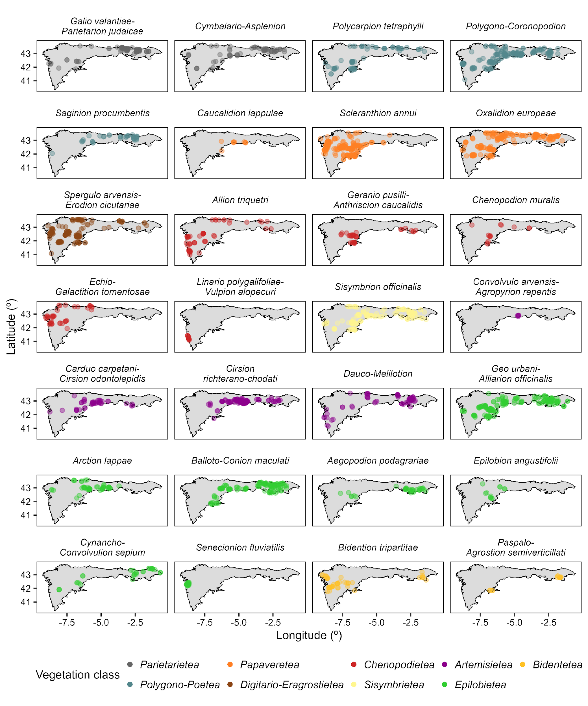

*Figure 1: Figure 1. Distribution of the anthropogenic alliances in the Iberian Atlantic ecoregion. Each dot represents a relevé. Dots are colored by vegetation classes.*

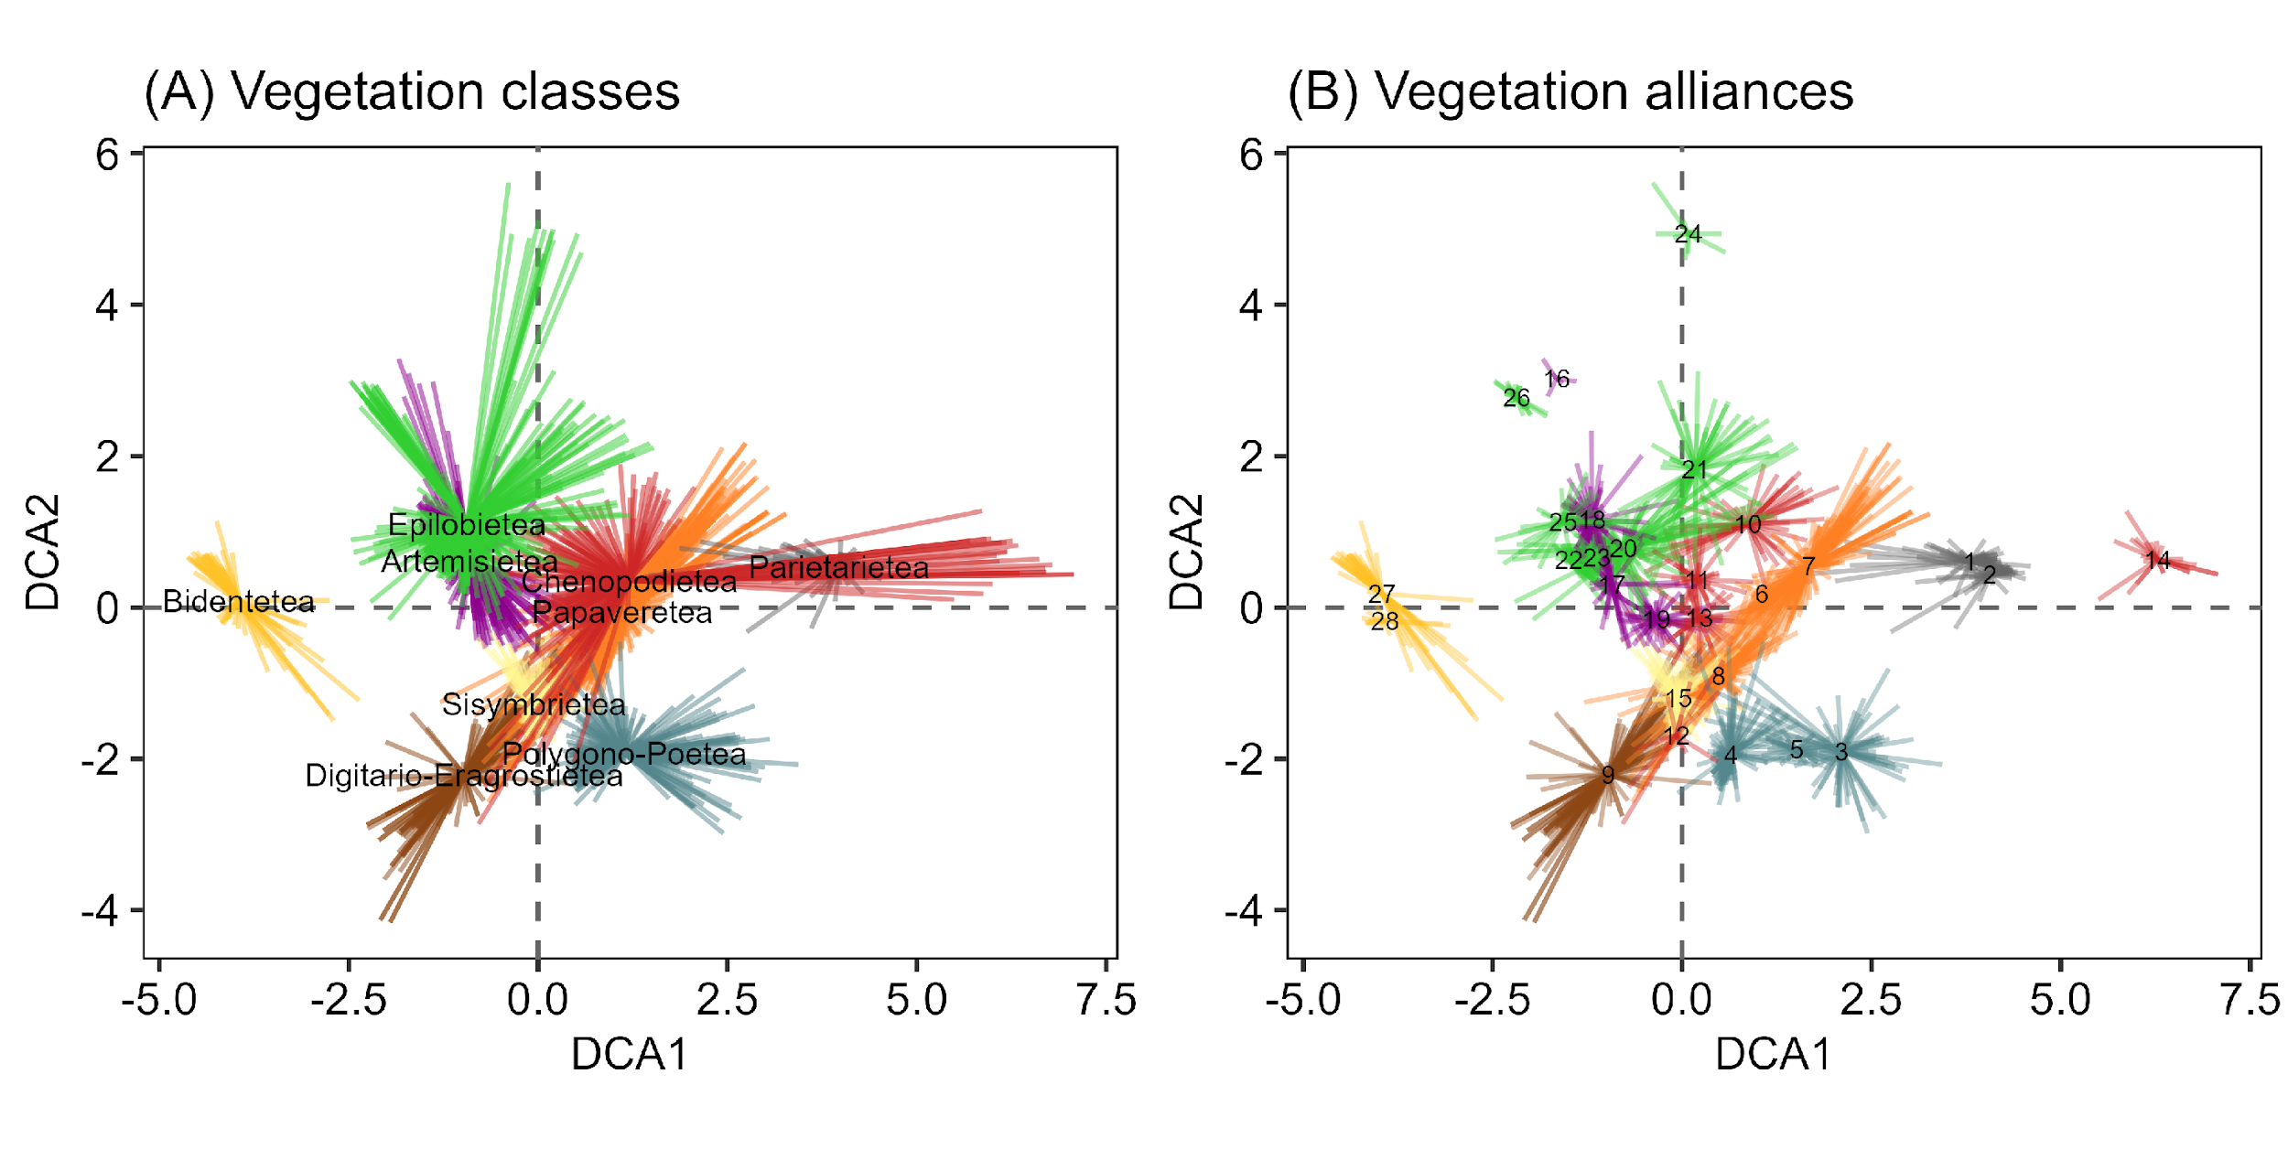

*Figure 2: Figure 2. Ordination of the floristic composition of the anthropogenic plant communities of the Iberian Atlantic ecoregion. The ordination is the results of a Detrended Correspondence Analysis grouped by vegetation classes (A, left) and alliances (B, right).*

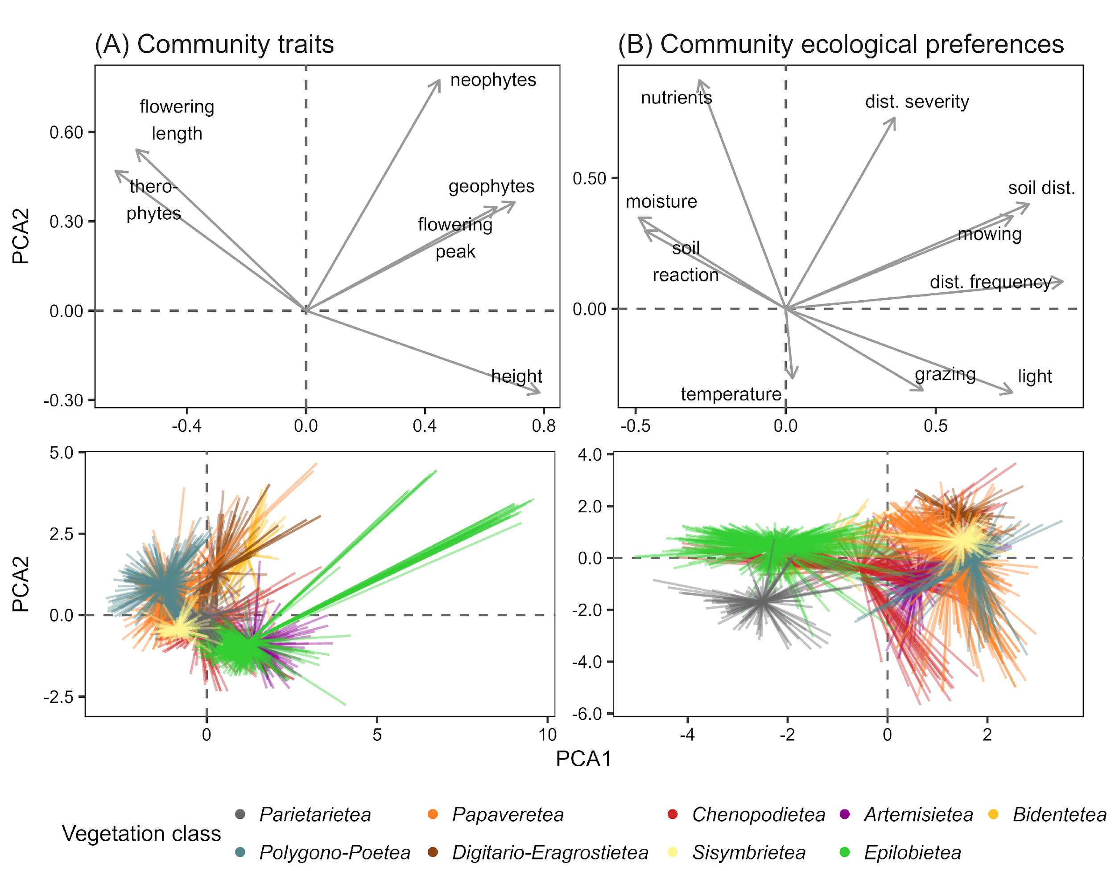

*Figure 3: Figure 3. Ordination of the community-level species traits and ecological preferences. The ordinations are the results of a Principal Component Analysis calculated for the community-weighted means for species traits (A, left) and ecological and disturbance indicator values (B, right).*

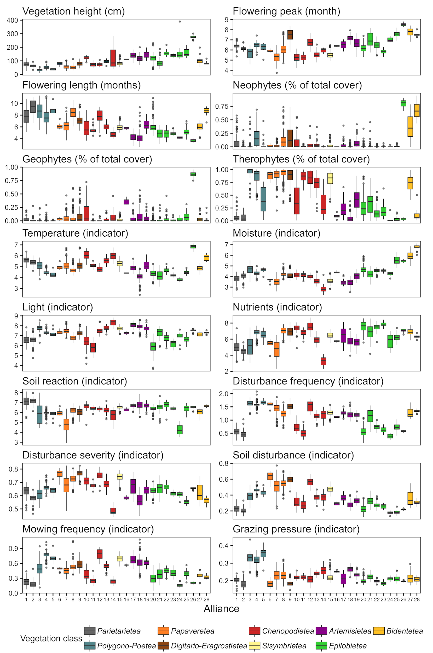

*Figure 4: Figure 4. Community-level species traits and ecological preferences by alliance. Boxplots calculated for the community-weighted means for species traits and ecological and disturbance indicator values.*